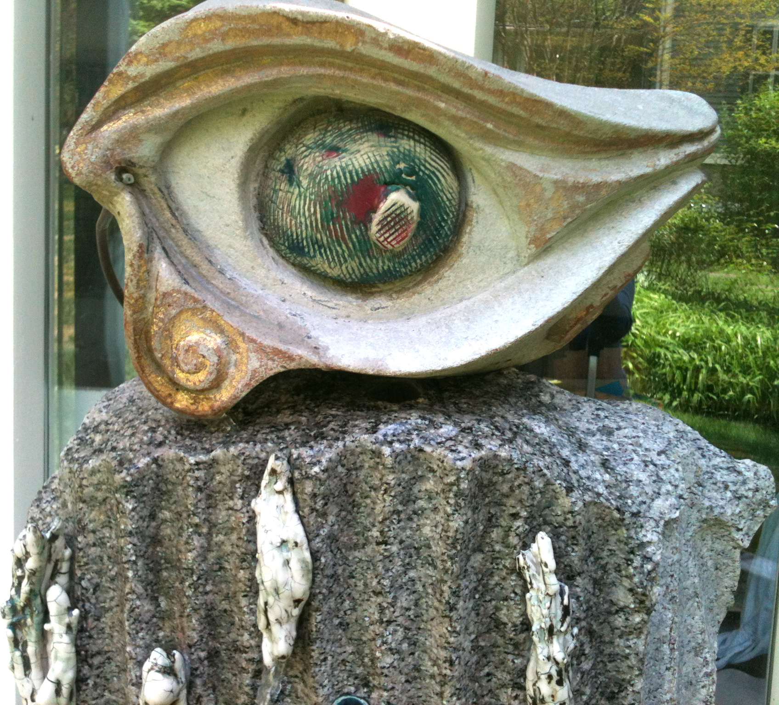
The Mind’s Eye
Fountain by Gay Hanna and Wendy Miller
The fountain, The Mind’s Eye, is a collaborative art piece by sculptors Gay Hanna and Wendy Miller. Installed at the entrance of the Kensington courtyard, the fountain is a welcome to the First Annual Morris L. Parker Art Festival, April 22, 2012. The fountain is constructed with elemental materials - metal, carved stone and fired ceramic. Through water, sound, and shape, The Mind’s Eye aims to convey our capacity to perceive with our whole being - physical, mental, emotional and spiritual – the fountain of wisdom as a wellspring of continuity, legacy and history.
Gay Hanna is a sculptor, writer and teacher. Her art is related to the architecture and landscape including the element of water to reflect and refresh the spirit. As well, she is the executive director of The National Center for Creative Aging (NCCA) an affiliate of George Washington University, which is dedicated to fostering an understanding of the vital relationship between creative expression and the quality of life of older people through education, research and policy development.
Wendy Miller is a sculptor, writer, expressive arts therapist and educator. Her art takes many forms, but her true love is clay and installation art. As well, she is the cofounder of Create Therapy Institute, which offers clinical services in arts-based psychotherapy, and trainings in the use of creativity and expressive arts in therapeutic practice.
Their collaboration has been years in the making. Contact: wendmiller@aol.com and ghanna@creativeaging.org

